**DEVELOPMENT PART-2 PHASE-4**

**PUBLIC TRANSPORTATION AND OPTIMIZATION**

|  |  |
| --- | --- |
| **DATE** | **26/10/2023** |
| ***PROJECT NAME*** | ***PUBLIC TRANSPORTATION AND OPTIMIZATION*** |

**JAVA:**

**The code given below is for the main class of the system**

import static java.awt.Frame.MAXIMIZED_BOTH;

import java.util.logging.Level;

import java.util.logging.Logger;

import javax.swing.ImageIcon;

import javax.swing.JFrame;

import javax.swing.UIManager;

import javax.swing.UnsupportedLookAndFeelException;

public class MainClass {

public static void main(String args[]) throws Exception{

//new frmSplash(3000);

UserInterface();

//ImageIcon will create a media tracker for you

Login_Window frame = new Login_Window();

frame.setLocation(400,300);

frame.setDefaultCloseOperation(JFrame.EXIT_ON_CLOSE);

frame.pack();

frame.setVisible(true);

frame.setResizable(false);

}

public static void UserInterface(){

try {

for (javax.swing.UIManager.LookAndFeelInfo info : javax.swing.UIManager.getInstalledLookAndFeels()) {

if ("Nimbus".equals(info.getName())) {

try {

javax.swing.UIManager.setLookAndFeel(info.getClassName());

} catch (InstantiationException ex) {

Logger.getLogger(StartPage.class.getName()).log(Level.SEVERE, null, ex);

} catch (IllegalAccessException ex) {

Logger.getLogger(StartPage.class.getName()).log(Level.SEVERE, null, ex);

} catch (UnsupportedLookAndFeelException ex) {

Logger.getLogger(StartPage.class.getName()).log(Level.SEVERE, null, ex);

}

break;

}

}

}catch(ClassNotFoundException ex){

ex.printStackTrace();

}

}

public static void UserWindowsInterface(){

try {

for (javax.swing.UIManager.LookAndFeelInfo info : javax.swing.UIManager.getInstalledLookAndFeels()) {

if ("Windows".equals(info.getName())) {

try {

javax.swing.UIManager.setLookAndFeel(info.getClassName());

} catch (InstantiationException ex) {

Logger.getLogger(StartPage.class.getName()).log(Level.SEVERE, null, ex);

} catch (IllegalAccessException ex) {

Logger.getLogger(StartPage.class.getName()).log(Level.SEVERE, null, ex);

} catch (UnsupportedLookAndFeelException ex) {

Logger.getLogger(StartPage.class.getName()).log(Level.SEVERE, null, ex);

}

break;

}

}

}catch(ClassNotFoundException ex){

ex.printStackTrace();

}

}

}

OUTPUT:l

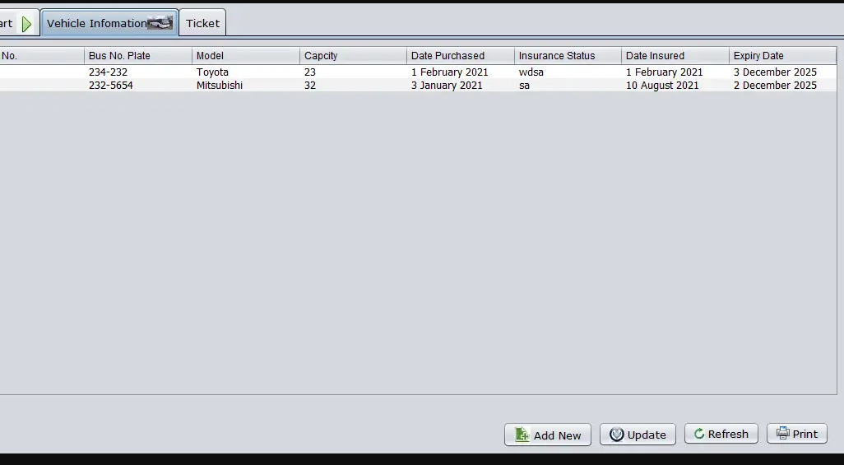

HTML:

1. <!DOCTYPE html>
2. <[**html**](http://december.com/html/4/element/html.html) lang="en">
3. <[**head**](http://december.com/html/4/element/head.html)>
4. <[**meta**](http://december.com/html/4/element/meta.html) charset="UTF-8">
5. <[**meta**](http://december.com/html/4/element/meta.html) name="viewport" content="width=device-width, initial-scale=1.0">
6. <[**title**](http://december.com/html/4/element/title.html)>Cool Hoverable Social Media Link | SourceCodester </[**title**](http://december.com/html/4/element/title.html)>
7. *<!-- Fontaweseome -->*
8. <[**link**](http://december.com/html/4/element/link.html) rel="stylesheet" href="https://cdnjs.cloudflare.com/ajax/libs/font-awesome/6.4.2/css/all.min.css" integrity="sha512-z3gLpd7yknf1YoNbCzqRKc4qyor8gaKU1qmn+CShxbuBusANI9QpRohGBreCFkKxLhei6S9CQXFEbbKuqLg0DA==" crossorigin="anonymous" referrerpolicy="no-referrer" />
9. <[**link**](http://december.com/html/4/element/link.html) rel="stylesheet" href="styles.css">
10. </[**head**](http://december.com/html/4/element/head.html)>
11. <[**body**](http://december.com/html/4/element/body.html)>
12. <main>
13. <[**div**](http://december.com/html/4/element/div.html) id="wrapper">
14. <[**h2**](http://december.com/html/4/element/h2.html) class="title">Cool Hoverable Social Media Link</[**h2**](http://december.com/html/4/element/h2.html)>
15. *<!-- SocMed Links -->*
16. <[**div**](http://december.com/html/4/element/div.html) id="soc-med-links">
17. *<!-- Social Media Link Item -->*
18. <[**div**](http://december.com/html/4/element/div.html) class="soc-med-links-item">
19. <[**a**](http://december.com/html/4/element/a.html) href="https://www.facebook.com/SourceCodester" target="_blank">
20. *<!-- Social Media Link Item Icon Element -->*
21. <[**div**](http://december.com/html/4/element/div.html) class="soc-med-links-item-icon bg-primary">
22. <**[i](http://december.com/html/4/element/i.html)** class="fa-brands fa-facebook-f"></**[i](http://december.com/html/4/element/i.html)**>
23. </[**div**](http://december.com/html/4/element/div.html)>
24. *<!-- Social Media Link Item Text Element -->*
25. <[**div**](http://december.com/html/4/element/div.html) class="soc-med-links-item-text">
26. SourceCodester
27. </[**div**](http://december.com/html/4/element/div.html)>
28. </[**a**](http://december.com/html/4/element/a.html)>
29. </[**div**](http://december.com/html/4/element/div.html)>
30. *<!-- Social Media Link Item -->*
31. <[**div**](http://december.com/html/4/element/div.html) class="soc-med-links-item">
32. <[**a**](http://december.com/html/4/element/a.html) href="https://twitter.com/intent/follow?original_referer=https%3A%2F%2Fwww.sourcecodester.com%2F&region=follow_link&screen_name=sourcecodester" target="_blank">
33. *<!-- Social Media Link Item Icon Element -->*
34. <[**div**](http://december.com/html/4/element/div.html) class="soc-med-links-item-icon bg-secondary">
35. <**[i](http://december.com/html/4/element/i.html)** class="fa-brands fa-x-twitter"></**[i](http://december.com/html/4/element/i.html)**>
36. </[**div**](http://december.com/html/4/element/div.html)>
37. *<!-- Social Media Link Item Text Element -->*
38. <[**div**](http://december.com/html/4/element/div.html) class="soc-med-links-item-text">
39. SourceCodester
40. </[**div**](http://december.com/html/4/element/div.html)>
41. </[**a**](http://december.com/html/4/element/a.html)>
42. </[**div**](http://december.com/html/4/element/div.html)>
43. *<!-- Social Media Link Item -->*
44. <[**div**](http://december.com/html/4/element/div.html) class="soc-med-links-item">
45. <[**a**](http://december.com/html/4/element/a.html) href="https://github.com" target="_blank">
46. *<!-- Social Media Link Item Icon Element -->*
47. <[**div**](http://december.com/html/4/element/div.html) class="soc-med-links-item-icon bg-dark">
48. <**[i](http://december.com/html/4/element/i.html)** class="fa-brands fa-github"></**[i](http://december.com/html/4/element/i.html)**>
49. </[**div**](http://december.com/html/4/element/div.html)>
50. *<!-- Social Media Link Item Text Element -->*
51. <[**div**](http://december.com/html/4/element/div.html) class="soc-med-links-item-text">
52. GitHub
53. </[**div**](http://december.com/html/4/element/div.html)>
54. </[**a**](http://december.com/html/4/element/a.html)>
55. </[**div**](http://december.com/html/4/element/div.html)>
56. *<!-- Social Media Link Item -->*
57. <[**div**](http://december.com/html/4/element/div.html) class="soc-med-links-item">
58. <[**a**](http://december.com/html/4/element/a.html) href="https://www.instagram.com/" target="_blank">
59. *<!-- Social Media Link Item Icon Element -->*
60. <[**div**](http://december.com/html/4/element/div.html) class="soc-med-links-item-icon bg-gradient">
61. <**[i](http://december.com/html/4/element/i.html)** class="fa-brands fa-instagram"></**[i](http://december.com/html/4/element/i.html)**>
62. </[**div**](http://december.com/html/4/element/div.html)>
63. *<!-- Social Media Link Item Text Element -->*
64. <[**div**](http://december.com/html/4/element/div.html) class="soc-med-links-item-text">
65. Instagram
66. </[**div**](http://december.com/html/4/element/div.html)>
67. </[**a**](http://december.com/html/4/element/a.html)>
68. </[**div**](http://december.com/html/4/element/div.html)>
69. *<!-- Social Media Link Item -->*
70. <[**div**](http://december.com/html/4/element/div.html) class="soc-med-links-item">
71. <[**a**](http://december.com/html/4/element/a.html) href="https://www.youtube.com/@sourcecodester247" target="_blank">
72. *<!-- Social Media Link Item Icon Element -->*
73. <[**div**](http://december.com/html/4/element/div.html) class="soc-med-links-item-icon bg-red">
74. <**[i](http://december.com/html/4/element/i.html)** class="fa-brands fa-youtube"></**[i](http://december.com/html/4/element/i.html)**>
75. </[**div**](http://december.com/html/4/element/div.html)>
76. *<!-- Social Media Link Item Text Element -->*
77. <[**div**](http://december.com/html/4/element/div.html) class="soc-med-links-item-text">
78. SourceCodester
79. </[**div**](http://december.com/html/4/element/div.html)>
80. </[**a**](http://december.com/html/4/element/a.html)>
81. </[**div**](http://december.com/html/4/element/div.html)>
82. </[**div**](http://december.com/html/4/element/div.html)>
83. </[**div**](http://december.com/html/4/element/div.html)>
84. </main>
85. </[**body**](http://december.com/html/4/element/body.html)>
86. </[**html**](http://december.com/html/4/element/html.html)>

### ****CSS :****

1. **@import** url('https://fonts.googleapis.com/css2?family=Exo+2:ital,wght@0,100;0,200;0,300;0,400;0,500;1,100;1,200;1,300;1,400;1,500&display=swap');
3. :root{
4. --bg-primary: #3876BF;
5. --bg-secondary: #4D4C7D;
6. --bg-red: #D80032;
7. --bg-dark: #352F44;
8. --bg-warn: #FBDA61;
9. --bg-gradient: linear-gradient(45deg, #FBDA61 0%, #FF5ACD 100%);
10. }
12. * {
13. **font-family**: 'Exo 2', sans-serif;;
14. }
15. */* Page Interface Design */*
16. html, body{
17. **width**: 100%;
18. **height**: 100%;
19. **margin**: unset;
20. **padding**: unset;
21. }
23. body{
24. **background-color**: #0093E9;
25. **background-image**: linear-gradient(160deg, #0093E9 0%, #80D0C7 100%);
26. }
28. main{
29. **width**: 100%;
30. **height**: 100%;
31. **display**: flex;
32. **flex-flow**: column wrap;
33. **align-items**: center;
34. **justify-content**: center;
35. }
36. #wrapper{
37. **width**: 100%;
38. **max-width**: 500px;
39. }
40. */* Page Title */*
41. h2.title{
42. **font-weight**: bold;
43. **color**:#fff;
44. **letter-spacing**: 0.3px;
45. **text-align**: center;
46. }
48. */* Social Media Links Styles */*
50. */* Social Media Links or Button Wrapper */*
51. #soc-med-links{
52. **display**: flex;
53. **flex-flow**: row wrap;
54. **min-width**: 100px;
55. **max-width**: 100%;
56. **column-gap**: 10px;
57. **justify-content**: space-between;
58. }
60. */* Social Media Link Item */*
61. #soc-med-links .soc-med-links-item {
62. **box-shadow**: 0px 3px 3px #0000003a;
63. **background-color**: #fff;
64. **border-radius**: 2rem;
65. **transition**: all .3s ease-in-out;
66. }
68. */* Social Media Link Item anchor tag Element */*
70. #soc-med-links .soc-med-links-item a{
71. **text-decoration**: none !important;
72. **color**:#352F44 !important;
73. **display**: flex;
74. **align-items**: center;
75. **justify-content**: center;
76. }
78. */* Social Media Link Item Icon/Logo Element */*
79. #soc-med-links .soc-med-links-item .soc-med-links-item-icon {
80. **height**: 50px;
81. **width**: 50px;
82. **display**: flex;
83. **flex-direction**: column;
84. **align-items**: center;
85. **justify-content**: center;
86. **border**: 1px solid #e8e8e8;
87. **background-color**: #fff;
88. **border-radius**: 50% 50%;
89. **font-size**: 2rem;
90. }
92. */* Social Media Link Item Text Element */*
93. #soc-med-links .soc-med-links-item .soc-med-links-item-text {
94. **font-size**: 14px;
95. **font-weight**: 600;
96. **letter-spacing**: .5px;
97. **overflow**: hidden;
98. **width**: 0;
99. }
101. */* Social Media Link Icon when Hovered */*
102. #soc-med-links .soc-med-links-item:hover .soc-med-links-item-icon{
103. **position**: relative;
104. **top**: 1px;
105. **left**: 1px;
106. **border**:unset;
107. }
109. */* Social Media Link when Hovered Colors */*
110. #soc-med-links .soc-med-links-item:hover .soc-med-links-item-icon.bg-primary{
111. **background-color**: var(--bg-primary);
112. **color**: #fff;
113. }
114. #soc-med-links .soc-med-links-item:hover .soc-med-links-item-icon.bg-secondary{
115. **background-color**: var(--bg-secondary);
116. **color**: #fff;
117. }
118. #soc-med-links .soc-med-links-item:hover .soc-med-links-item-icon.bg-dark{
119. **background-color**: var(--bg-dark);
120. **color**: #fff;
121. }
122. #soc-med-links .soc-med-links-item:hover .soc-med-links-item-icon.bg-red{
123. **background-color**: var(--bg-red);
124. **color**: #fff;
125. }
126. #soc-med-links .soc-med-links-item:hover .soc-med-links-item-icon.bg-gradient{
127. **background-color**: var(--bg-warn);
128. **background-image**: var(--bg-gradient);
129. **color**: #fff;
130. }
132. */* Adding animation when hovering */*
133. #soc-med-links .soc-med-links-item:hover .soc-med-links-item-text{
134. **animation**: expandingAnimation .5s ease forwards;
135. }
137. */* Expanding the Link Text Animation */*
139. **@keyframes** expandingAnimation {
140. 0%{
141. **width**: 0;
142. **margin**: 0px 0px;
143. }
144. 100%{
145. **width**: auto;
146. **margin**: 5px 10px;
147. }
148. }

Ezoic